OPM3®ProductSuite Experience Requirement Screening

The qualification process for a candidate PMI Certified OPM3 Assessor/Consultant up to the first year’s certification has three steps.

The first step is referred to as “Entrance Assessment” and has two elements: the Entrance Exam and the Experience Requirement Screening (ERS). All candidates must pass these two elements.

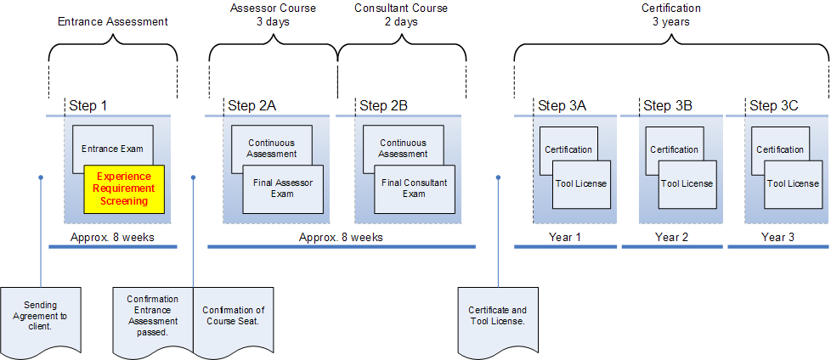

In addition to the Entrance Examination, the objective of the ERS is to assess if the candidate has the right level of experience and expertise to enter the Assessor/Consultant Course and thus be able to participate with peers in the learning process in order to be qualified as an Assessor/Consultant on the additional OPM3 and assessment/improvement tool related requirements.

The objective of this document is to provide sufficient information for a candidate PMI Certified OPM3 Assessor/Consultant to prepare for the ERS and submit the Application Form for the Experience Requirement Screening and necessary documents correctly and completely.

Whether applying for “PMI Certified OPM3 Assessor” or “PMI Certified OPM3 Consultant”, all applicants must state and submit their experience and expertise with respect to:
- Project Management experience as Project Leader and/or Project Manager (2500+ hours),
- Assessment experience as Assessment Team Leader/Member (250+ hours) and
- OPM3 (Self) Assessments (at least one executed).

Candidates applying for “PMI Certified OPM3 Consultant” must, in addition to the experience and expertise mentioned above, state and submit their experience and expertise as a:
- Business Process Improvement/Performance (Senior) Consultant (500+ hours).

IMPORTANT NOTES:
A. if you, (the applicant) hold a credential as PMI certified PMP and/or IPMA certified Level A or B, valid at the date that you apply for entering the qualification process for PMI Certified OPM3® Assessor/Consultant, the requirement to submit your expertise mentioned under 1) is waived. Please state your registration number/certification number/member number on the Application Form for the Experience Requirement Screening and skip section 1.B of that form.
- if you, (the applicant) hold a credential as an IRCA registered Auditor/Assessor, an IEMA registered Auditor/Assessor, an RAB (Lead) Auditor/Assessor, an Automotive Auditor/Assessor, a CMM/CMMI Assessor and/or a TickIt auditor/Assessor valid at the date when you apply for entering the qualification process for PMI Certified OPM3 Assessor/Consultant, the requirement to submit your expertise mentioned under 2) is waived. Please state your registration number/certification number/member number on the Application Form for the Experience Requirement Screening and skip section 2.B of that form.
- If you, (the applicant) apply for PMI Certified OPM3 Consultant, your Business Process Improvement/Performance Projects may also be submitted as Projects the same time.

FILLING IN YOUR APPLICATION FORM for the EXPERIENCE REQUIREMENT SCREENING:

General Section (mandatory)
As a candidate PMI Certified OPM3 Assessor/Consultant you will need to submit the Application Form Résumé/Curriculum Vitae, stating your:
a: Title/Salutation, Name (first, given and family name) and current/correspondence address
b: Date of birth and place of birth (City, State and/or Country)
c: Relevant experience (mentioning dates) in Project Management, Execution of Organizational Assessments and (applicable for candidate Consultants) organizational/business improvement/performance consultancy projects. These experiences must be noted on the relevant summary forms which you can download from this site.
d: Relevant diplomas and other credentials.

Note: your CV must be limited to 4 pages. DNV will archive all submitted documents for qualification purposes only for a period of four years after which all documents will be destroyed. No documents will be returned. Do not submit original documents. All applications are subject to random audits.

Section 1: Project Management Experience (mandatory)
As a candidate PMI Certified OPM3 Assessor/Consultant you must state your experience as Project Manager and/or Project Leader in the last five years prior to the date of applying for/entering the qualification process for PMI Certified OPM3 Assessor/Consultant.

DNV will assess if your experience, based on the submitted Project Summary Forms is sufficient. Only five Projects, submitted through the Project Summary Forms will be taken into consideration.
You must have been involved in over 2500+ hours of project management, the major part of these hours in the role or position as Project Leader or Project Manager.

Section 2: Assessors Experience (Mandatory)
As a candidate PMI Certified OPM3 Assessor/Consultant you must state your experience as an assessor while executing organizational or business performance assessments in the last five years prior to the date of applying for/entering the qualification process for PMI Certified OPM3 Assessor/Consultant. You must have been involved in over 250 hours of executing assessments, the majority of these hours in the role or position as overall Assessment Team Leader. DNV will assess if your experience, based on the submitted Assessment Summary Forms is sufficient.
A maximum of 15 Assessments, as described on the Assessment Summary Forms will be taken into consideration when assessing your experience as an Assessor.

Section 3: OPM3 (Self) Assessment (Mandatory)
In addition to the assessments mentioned above, you will need to have conducted at least one OPM3 Assessment in which you have worked on the best practices and capabilities level. This Assessment may have been a real life assessment or a staged one. You will need to fill in the OPM3 Assessment Summary Form.

Section 4: Business Process Improvement Consultant Experience (mandatory when applying for PMI Certified OPM3 Consultant)
As a candidate PMI Certified OPM3 Assessor/Consultant you must state your experience as a business process improvement/performance Consultant in the last five years prior to the date of applying for/entering the qualification process for PMI Certified OPM3 Consultant.

DNV will assess if your experience, based on the submitted Consultant Summary Forms is sufficient.
Only five Business Process Improvement/Performance Consultancy projects (as described on the Consultant Summary Forms) will be taken into consideration when assessing your experience as a Consultant.
As a rule of thumb, you must have been involved in over 500 hours of consultancy, the major part of these hours in a role or position as overall Consultant Team Leader/Senior Consultant.
DNV must be able to verify the projects and your experience through references that you have presented on the Consultant Summary Forms.

Note: as relevant consultancy projects the following are accepted: business performance improvement projects, management system implementation projects (e.g. related to regional, international or industrial standards), change-projects due to organizational re-structuring and/or merging.

Notes:
DNV must be able to verify and validate the compliance of each above mentioned experience requirements through initial screening of the submitted summary forms. All applicants and materials are subject to random audits. The applicant may be requested to provide additional information to DNV. DNV reserves the right to verify, to the degree deemed necessary, any or all the statements you make by submitting this application, including requesting additional documentation and credentials.

When the applicant’s Application Form for the Experience Requirement Screening is received by DNV, it will be processed and DNV will send the applicant a letter stating the outcome of the Experience Requirement Screening within 15 workdays (provided the application is correct and complete and no additional information was requested).

